What is the Pareto principle?
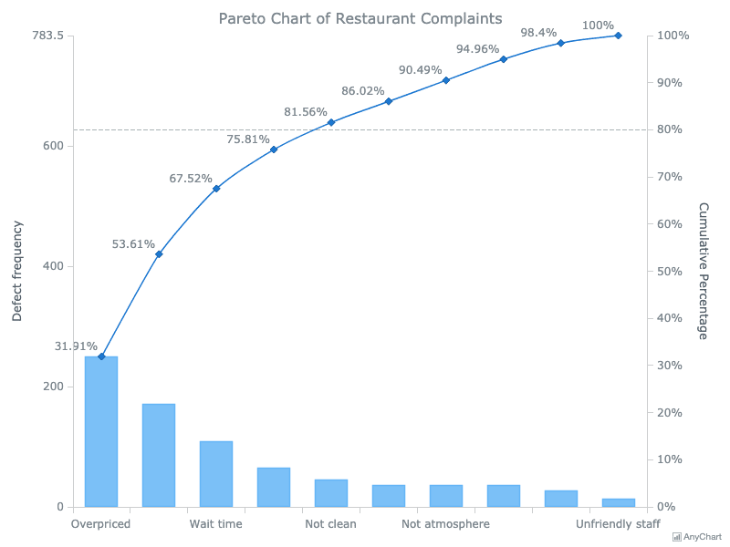
Also called the 80/20 rule, the Pareto principle says that in many instances 80% of the effects come from 20% of the causes. The most efficient way to improve, therefore, is to focus efforts on the few causes that have an outsized effect. For instance, a small number of key problems cause a large percentage of errors. Nearly any improvement project could benefit from the application of the Pareto principle

What is a Pareto chart?
A tool borrowed from Six Sigma and total quality control, a Pareto chart highlights the most important issues from a series of factors by categorizing data and sorting it by the most frequent categories. In other words, you simply break your data down into categories (say, “type of customer complaints”) and sort it by the most frequent categories. For example, a Pareto chart would allow you to say, “In a month, our customers complain about dozens of different types of issues, but more than half of complaints are about billing, the website, or courtesy.” It is usually shown as a bar graph, sorted by most frequent to least frequent category, with a line graph superimposed showing the cumulative total (see example at right).

When should I use it?
Anytime you have a recurring issue that can be categorized, a Pareto analysis can potentially help. It is a particularly useful tool for focusing on elimination of errors in a process.

For instance, a Pareto chart can show:
- What form fields do customers fill out incorrectly most often?
- What are the most common reasons for rejected applications?
- What are the common customer complaints? What divisions or services are the subject of most complaints?
- Which departments / neighborhoods / employee groups drive most requests for service?

When it comes to errors or complaints, anecdotes about really egregious or annoying problems sometimes obscure the most common day-to-day problems. Putting real numbers to problems takes anecdotes out of the equation. Having a quality data source is great, but not necessary: A powerful Pareto analysis can be constructed from a hand-drawn tally sheet just as well as a fancy database.

Examples from the Lean Team
Here are some examples of where client departments have used Pareto analyses:
- The SF Public Library HR team found that their two most common job classifications (entry level librarians and pages) made up nearly 50% of all SFPL staff. Improving time-to-hire for just those two positions would have an outsized effect on overall time-to-hire. (In this example, the Pareto chart showed number of staff by job classification.)
- The Health Service System team discovered that nearly three-quarters of City staff at risk of losing health benefits were from just three City departments. They were then able to invite leave coordinators from those departments to a workshop to improve leave practices. (In this example, the Pareto chart showed number of delinquent accounts by City departments.)
- The Health Service System team also looked at the cost-benefit of recouping benefit premiums from members who were delinquent. They found that nearly 50% of delinquent accounts owed less than $50, and a quarter owed less than $10. They were then able to explore waiving small amounts owed to focus staff time on recouping the smaller number of high-value delinquencies. (In this example, the Pareto chart showed number of delinquencies by ranges of amounts owed, e.g. $1 - $10, $11 - $20, etc.)
- Trade supervisors at the Rec Park Structural Maintenance Yard kept a hand tally for several weeks of maintenance work orders submitted with errors. They found that two-thirds of work orders that were incomplete or inaccurate were due to three problems: the location of the issue was unclear, the type of material was unclear, or the project size was unclear. They were able to tailor changes to the work request form to reduce these errors. (In this example, the Pareto chart showed incomplete or inaccurate work orders by the type of error.)

A Pareto analysis from the Structural Maintenance Yard

How do I create it?
- Collect some data
Ideally the process issue or error you’re interested in is tracked somewhere. Get an export out of your database that can show fields that you’re interested in.
But what if I don’t have any data?
Create it! A simple tally sheet is often all you need to produce a good-enough Pareto analysis. Here are some ideas for how you can manually collect data:
- Commit to tallying up customer questions you receive in your email inbox or via phone calls for a week.
- Have the front desk staff write down all the questions lobby patrons ask in a week.
- Have eligibility workers note for a week every time they have to correct a mistake and why.
- Look through an old pile of paper applications, forms, etc. and categorize by hand. (This may take one or two hours, but it is often less time consuming than researching a systems solution.)

- Stratify your data
Once you have some data, break it out by the category of interest. The goal is to identify a few causes that drive much of the problems, so that you can target solutions. For example, can you identify that most of your errors are on a particular part of the process? Coming from a particular location or type of customer? Coming from particular staff or internal divisions?

- Graph it
Once you have categorized data, just put it into a bar graph, sorted by the largest category to the smallest. You can also overlay the line graph on top of it to demonstrate the cumulative frequency. You can use the Pareto chart Excel template on our website as a starting point.
- Attack the frequent causes
Once you can hone in on the few causes responsible for the majority of problems, attack them with a laser focus!
Hints
- Fun fact: The Pareto Chart is one of the “seven basic tools of quality” as defined by organizational theorist Kaoru Ishikawa. Those seven tools (check sheets, control charts, stratification, Pareto charts, histograms, fishbone diagrams, and scatter plots) were inspired by the seven weapons of Japanese warrior monk Benkei.
Figure 1: An analyst getting ready to make a Pareto Chart.

